REVISED FOR CONTEXT 30 July 2026

Chapter 2

RAMP-TRIM Users Manual

Series of Records

United Nations Children’s Fund
3 United Nations Plaza
New York, New York 10017

Chapter 2. Series of Records

Table of Contents

2.1 What is a Series? 4
2.2 Self-Test: Series Identification 4
2.3 How to Start a Series 4
2.4 Tasks Associated with Record Series 5
2.4.1 Identifying or List a Record Series 6
2.4.2 Adding a Record Series 9
2.4.3 Modify a Existing Record Series 14
2.4.4 Adding Several Series at Once (Copy Functions) 14
2.4.5 Modifying an Entire List of Record Series (Tag and Task Functions) 16
2.4.6 Printing a Record Series List 17
2.5 Record Series Exercises 19
2.6 Key Learning Points 21
2.7 Self-Test: Series Identification 21

List of Figures

Figure 1. Tag-and-Task 6
Figure 2. Sorting the Search Results 7
Figure 3. Series Search Screen Error! Bookmark not defined.
Figure 4. Select the Record Type 8
Figure 5. Record View and Record List Panes 8
Figure 6. Record Series Entry Form 9
Figure 7. Save a Series Record Error! Bookmark not defined.
Figure 8. Search Results 14
Figure 9. Task Menu Error! Bookmark not defined.
Figure 10. Record Series Title Edit Screen Error! Bookmark not defined.
Figure 11. Extra Details Error! Bookmark not defined.
Figure 12. Record Series Date Field Edit Screen Error! Bookmark not defined.
Figure 13. Folder Record Notes Edit Screen Error! Bookmark not defined.
Figure 14. Results of a Series Search Error! Bookmark not defined.
Figure 15. Copy a Series Record Error! Bookmark not defined.
Figure 16. Copy Series Fields 16
Figure 17. Tag-and-Task 17
Figure 18. Task Selection List Error! Bookmark not defined.
Figure 19. Selecting Report Options 18
Figure 20. Report List 18

2.1 What is a Series?

Many work units have created more than 100 record folders, and with this volume it can become difficult to locate a particular record and retrieve it. Creating record categories will permit you to organize records with common characteristics. By organizing record folders into a few general categories, it is possible to narrow the search, thus increasing speed and efficiency. These general categories are called Series.

The RAMP-TRIM data system is organized and maintained primarily according to this logic of efficiency. Although a work unit may have thousands of file folders, it will only have a handful of series. If the appropriate series of records is located first, it is then easy to find a particular folder.

2.2 Self-Test: Series Identification

Some of the general features of a series of records include the following:

A) A group of records that is maintained together and either relates to a particular function (e.g. processing "purchase orders") or results from the same activity (e.g., "International Year of the Child" in 1979, or "World Summit for Children" in 1990).

B) A group of records that is maintained together and has a particular form (e.g. binders, file folders, microfiche, video cassettes, audio cassettes, data disks).

C) A group of records that is maintained together and has a similar retention period (e.g. papers from the Executive Director's Office might be separated into administrative subjects that are only kept for 7 years and into correspondence from heads of state, which could be kept permanently).

Retention period is the most important criteria for managing records over time. It tells us how long different types of records must be legally kept. In order for a correct appraisal to be made concerning retention, a series must be accurately described.

2.3 How to Start a Series

If one is unsure what to name a first series, the easiest way to proceed is to create a vague title such as "General Subjects", or something similar (e.g. "To Be Determined", "Initial Series", etc.). As the number of folders increases (usually around 100), it will become apparent what categories of records are going to become major areas of interest for the particular work unit. They can then be separated and form independent series. You will see later that it is easy to change or modify the series title as the need arises.

If for some reason maintenance of records is shifted from one work unit to another, it is not necessary for the new unit to re-enter all the data. Contact RAMP-TRIM Administration and they will help with the transfer. Also, within existing series, sub-series can be created to further define the record series hierarchy.

Some of the most common series titles in use at UNICEF are:

- General Subject Files
- Personnel and Training
- Budget and Finance
- City or Country Folders
- Policy Procedure and Practice
- Special Projects
- Working Papers
- Folders to be Assigned
- and Retired Files (RET)

Summary Series of Records

There are five operations that are commonly performed when adding or modifying series of records in the RAMP-TRIM application.

Adding a Record Series

Modifying an existing Record Series

Adding several Series at once (Copy Record)

Modifying an entire list of Series (Tag/Task)

Printing a list of Series

The following procedures describe these RAMP-TRIM processes and have screen captures that illustrate the actions.

2.4 Tasks Associated with Record Series

You will conduct a number of different tasks when managing the record series list. In the processes described here it will be necessary to record information about the series.

2.4.1 Identifying or Listing a Record Series

It is easy to search and list the series for a specific work unit in the RAMP-TRIM application. Use the following procedure to display record series sorted by the organization:

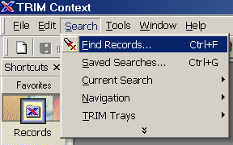
Figure 1. Search – Find Records…

1. At the RAMP-TRIM Menu Bar navigate to Search, Find Records, and search method by Contact (Hint the Contact field is also found in the Locations field which is found using the Kwikselect button).

2. Enter the Contact name in search fields titled Location.

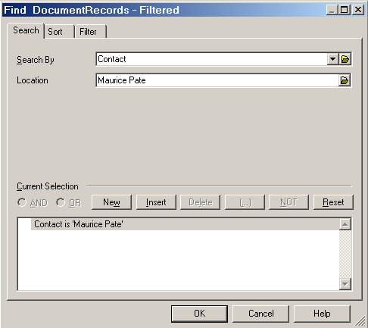
Figure 2. Search by Contact

Alternate Method: Use the Kwikselect folder icon to open the locations directory table and search for the Contact by name. This concept was introduced in Chapter 1.

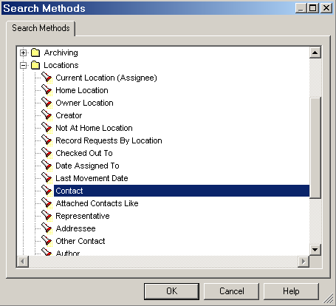
Figure 3. KwikSelect Heirarchical viewpane

3. Use the Sort function to designate the sequence in which series will be presented. Use the first Sort Field(s) number 1. Typically you will select sort by Date Registered, Record Series – Series Title or the External Reference Number in ascending order. Ascending order is the default value. The sort order can be changed to descending by checking the check box.

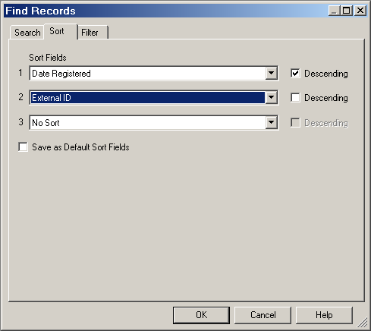
Figure 4. Sorting the Search Results

4. Select the Filter tab in the search panel and tag only the Record Type titled [Series]. Select OK to close the Select Record Type panel. Note that the Record Type selection can be set as a default value by checking the box titled Save as Default value.
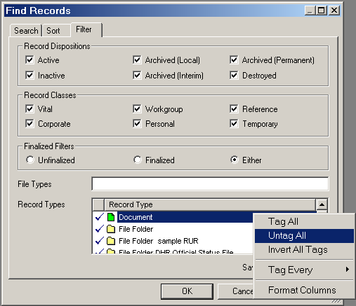
Figure 5. Select the Record Type

5. Select OK to conduct the search. Review additional information concerning a Record Series by highlighting the series record in the Record List Pane (search results panel above) and reviewing the detailed information in the Record View Pane (search results panel below).

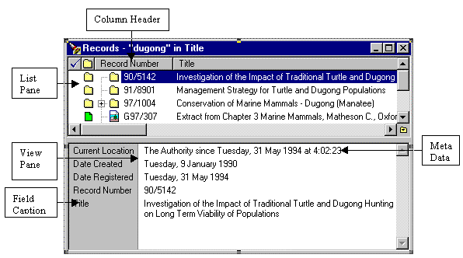
Record List Pane
Record View Pane – Contains Detailed Information
Figure 6. Record View and Record List Panes

2.4.2 Adding a Record Series

Each business unit will have standard Record Series that apply to their normal business activity. As time goes by, units may be assigned new duties, find new areas of interest, or find that an existing series have become too extensive and unwieldy. At this point, a new Series should be created. It is easy to add a Series. A new Series is added to the RAMP-TRIM application using the Record Series Entry form.

The following steps describe the process for completing the Record Series Entry Form:

- At the RAMP-TRIM Menu Bar navigate to File, New…, select Series and select OK to display the Records Series data entry form.

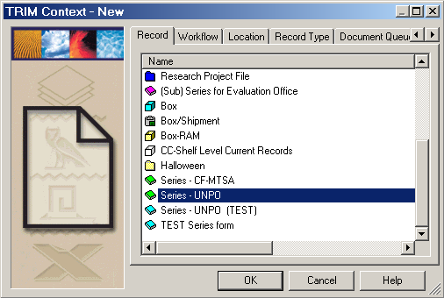

Figure 7. New Record list of types

- Complete the New Series Entry Form. The following fields are available on the New Series Entry form and may be filled out when preparing the series record. Some fields are required [R], have default values [D], are optional [O] or have a combination of both.

General Tab

Record Series - Title [R]: The title (alpha-numeric) title applied to the series and helps in identification of documents or records found in the series. This is a required field.

External Reference Local Series Year-Numb [O]: Remember to keep this entry short and do not repeat information already recorded in the Title field. Work unit prefix and year-number (and any other information you want to include). Strongly recommended.

Record Series Description [O]: Descriptive text contributing to an understanding of the series records or how the series is used.

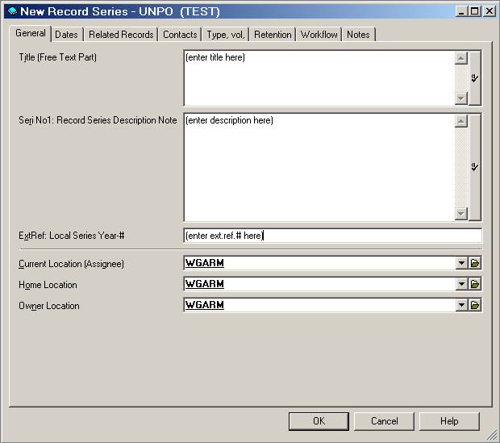
Figure 8. New Series General Tab

Current Location [R/D]: Where the record currently resides. The field value will default to the division, unit or organisation. Use the Kwikselect feature to identify the value in the organisation directory (locations).

Home Location [R/D]: Where the record resides when it is not in use. The field value will default to the division, unit or organisation. Use the Kwikselect feature to identify the value in the organisation directory (locations).

Owner Location [R/D]: The organisation, unit or individual that has overall responsibility for the series or series record (usually who/where it was created). The field value will default to the division, unit or organisation. Use the Kwikselect feature to identify the value in the organisation directory (locations).

Dates Tab

This tab contains the relevant dates associated with the record.

Date Registered [R/D]: The date that the record was input into TRIM. This normally equates to the date received and defaults to today’s date.

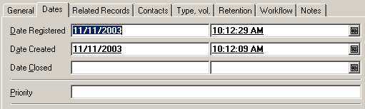
Figure 9. Dates Tab

Date Created [R/D]: The date series or series records were (physically) created. For example, the date the letter or document was written. The field also defaults to today’s date.

Date Closed [R/D]: The date series or series records were closed. The field is populated automatically. This field cannot be dated before the date created.

Priority [O]: A priority setting. Field is populated manually and the value is optional.

Related Records Tab

This dynamic field shows related records, which can be added/managed by right-clicking in the field.

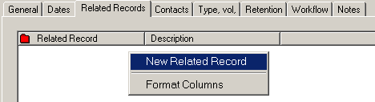
Figure 10. Related Records Tab: right-click to relate to another record

Contacts Tab

This dynamic field shows all contacts, which can be adjusted by right-clicking in the field. It typically contains contact information such as Author (which can be set to populate automatically) and other contacts who are related to the record.

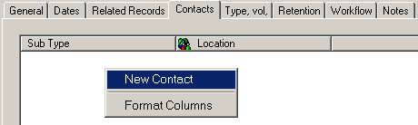
Figure 11. Contacts Tab: right-click to add a new contact

Type, Vol, Tab

This tab offers opportunity to enter further information on the type of record. The fields correspond with the Records Inventory Form.

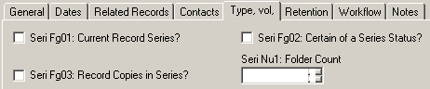
Figure 12. Type, vol. Tab

Fg1, Current Record Series? [O]: A check mark in this status field indicates the record is a current record series.

Fg2, Certain of Series Status? [O]: A check mark in this status field indicates you are certain of the series status.

Fg3, Record Copies in Series [O]: A check mark in this status field indicates the records are official copies or “Record Copies.”

Retention Tab

This tab contains fields for retention and storage details. Like the Type, vol. Tab, it also corresponds to the Records Inventory Form.

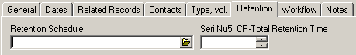
Figure 13. Retention Tab

Retention Schedule [O]: Contains the retention schedule numbers. The field is populated manually with input from the RAMP-TRIM administrator and the value is optional.

Workflow Tab
(This will be covered in a later chapter)

Notes Tab

The Notes tab allows you to enter any other details or information that usually cannot be placed in any of the other available fields. When a notation is made in the Notes field, the User Stamp should be used to keep an accurate audit trail by noting the date, time and author of the notation.

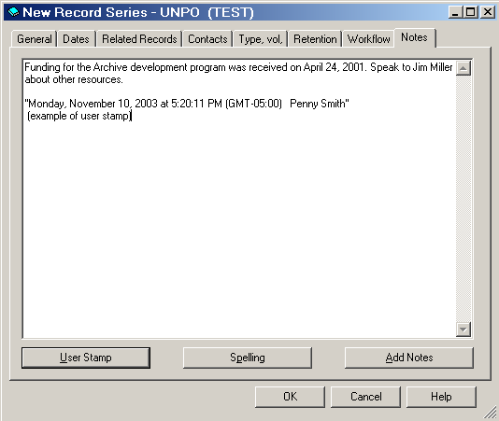
Figure 14. Notes Tab

When finished entering information in all the tabs, click the “OK” button and the Record Series is automatically numbered, although you may be given a prompt to confirm record numbering. Select OK to create the record, or Cancle to return to the record entry form.

Note: It is possible for a user to create a record with a higher security level than they have access to, however they will not be able to view the record after its creation. Contact the RAMP-TRIM Administrator

2.4.3 Modify an Existing Record Series

It may become necessary to update or modify an existing Record Series. Series records, in fact any RAMP-TRIM record item, are modified by double-clicking on the particular series in the List Pane or right-clicking on the particular series/item and selecting Properties. The properties dialog box for the series/item then appears for editing. Any of the information fields can be modified by an authorized user, e.g. title, notes, and related records.

Search for and identify the desired record series.

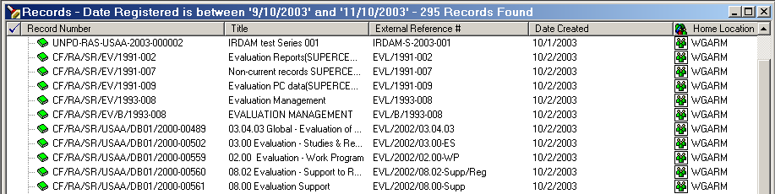
Figure 15. Search Results

The most common series maintenance tasks include title, location, related records, notes and dates.

Dates Modify Open the Dates tab and edit dates as appropriate. The small calendar icon to the right of the field opens up monthly calendars to easily select dates.

Notes Modify – Double click on the series in the List Pane and open the Notes Tab and edit notes as appropriate. You can enter up to 30,000 text characters. This is a text field and has no word processing functions. Do not format this field. Apply spell check with the button on the bottom.

2.4.4 Adding Several Series at Once (Copy Functions)

If a work unit is entering their records into the RAMP-TRIM application for the first time or rearranging their records, it may be advisable to enter several new series at once. This process makes it unnecessary to repeat the same steps over-and-over; this efficiency is achieved through the use of the copy record key. Several new Series are added to the RAMP-TRIM system at the same time by using the following steps:

Conduct a search as described in Section 2.4.1, Identifying or List a Record Series and highlight the desired record.

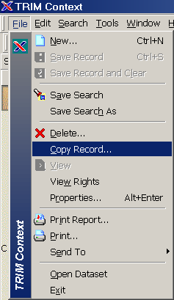
Figure 16. Copy a Series Record

Navigate to the Menu Selection File, Copy Record. If a pop-up dialogue box appears asking which records to “Apply To:”, make sure that the Current Record Only radio button is and select OK:

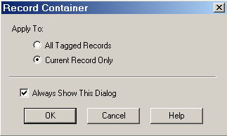
Figure 17. Determine which record(s) will be copied

In the next copy screen, select the qualities (fields or characteristics) to copy. Generally copy all fields unless it is necessary to change the field values.
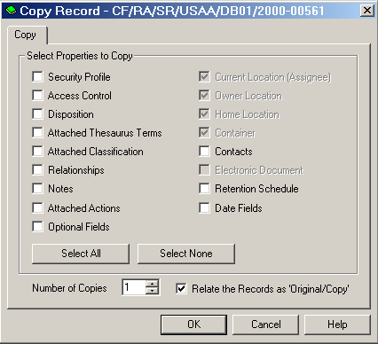
Figure 12. Copy Series Fields

Select the number of copies to generate. Special note: exact copies of the records will be produced and it will be necessary to manually annotate each series record copy to make them unique.

2.4.5 Modifying an Entire List of Record Series (Tag and Task Functions)

If a work unit is planning extensive reorganization, or is updating their records, it may be advisable to use a group change process of modifying basic series information, e.g. year, number, or title at the same time.

This procedure is called tag-and-task in RAMP-TRIM.

First find the desired records by conducting a search as described in Section 2.2.1, Identifying or List a Record Series.

Tag the records by locating the mouse just to the left of the series icon. Depress the left mouse button to activate or deactivate the bluecheckmark – this is the selection indicator. Alternatively, move the cursor to the right of the series icon and use the right mouse button to tag or untag all records in the Record View Pane.

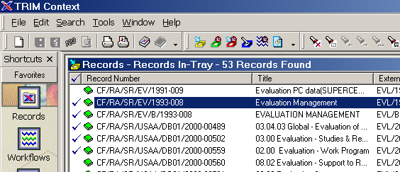
Figure 13. Tag-and-Task

Any task now performed will apply to all tagged records (when the “Apply to: All Tagged Records” prompt is selected). Refer to the Basic Ramp-Trim Operations in Annex A.

2.4.6 Printing a Record Series List

You may wish to print a Record Series report. This report, and many others, may be used by members of the organization. Use the following procedures to print reports.

- Conduct a search as described in Section 2.2.1, Identifying or List a Record Series.

- Select a series by highlighting or select several series records using the tag-and-task function.

- Navigate to the Menu selection File (Alt.F), Print Report ( Ctrl-R), select the report titled CF Series. Enter an Optional Title to provide a unique header and Select Preview and/or Print Report.
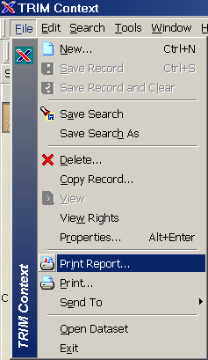
Figure 20. Print Report in the File Menu

The reports found in the RAMP-TRIM, File, Print Report are standard reports. Reports can also be customized for unique needs. Consult with the RAMP-TRIM Systems Administrator for information concerning customization of RAMP-TRIM reports.

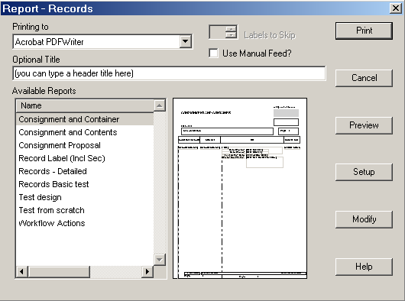
Figure 21. Report List and Options

2.5 Record Series Exercises

In Class Exercises

A) You have been assigned to TEST Work Unit___, in Test Section ___, in Test Division ___, in Ruratania Sub Office = RURS.

B) Using RAMP-TRIM, find the work unit and go to list of Series, and:

1. Add the Series:

Ext. Ref. Year-Numb [your Logon ID] | Title/Description
Rur/1985 003 [your ID] | Administrative Subjects (Ret)
Rur/1985 004 [yourID] | Personnel Subjects (Ret)
Rur/1992 001 [yourID] | Special Projects

2. Modify Series:

CHANGE: 1985 003 Administration Subjects (Ret)"
To: 1986 003 General Admin Subj (RET)"

Change: 1985 004 Personnel Subjects (Ret)"
To: 1986 004 General Personnel Subj (RET)"

3. Copy Record to Add 2 Series: (Edit)
(Copy record)

Rur/1991 002 Administration Working Papers
Rur/1991 003 Administration High Priority Projects

4. Edit/ Change Multiple Records

Change year 1991 to 1990 for each series and insert the word "test" in the beginning of both Series' titles. For Example:

Change: Rur/1991 002 Administration Working Papers
Rur/1991 003 Admin High Priority Proj"

To: Rur/1990 002 test Administration Working Papers
Rur/1990 003 test Admin High Priority Proj"

5. Make Changes to Multiple Records

Search for multiple records that were just created, e.g. Rur/1991 002 and 003. Add a note to both records with the text as follows. Note: “These series record were created by [your name] today [May 8, 2000] for the purposes of managing the unit’s records series.”

2.6 Key Learning Points

Determining Features of a Series

Series are a group or cluster of records (folders) that:

- Are maintained together,

- Relate to a particular function,
(e.g. processing purchase orders.)

- Result form a specific activity,
(e.g. World Summit, IYC - 1979),

- Are of a specific form,
(binders, folders, microform, disks, etc.)

- Have the same Retention Period

Note: Retention Period is most important for managing a series over time. In order to determine retention, a series must be well described.

2.7 Self-Test: Series Identification

Review of Chapter 1.

1. Q. What three ways are possible to find your work unit?
A.

2. Q. What is the difference between the "Work Unit" and the "Series of Records"?
A.

Review of Chapter 2.

1. Q. Why are records organized into series?
A.

2. Q. What are the determining features of a series?
A. 1)
2)
3)

3. Q. What are some of the main series in most work units?
A.

4. Q. Which series should all units have to start?
A.

5. Q. What do you do about "Working Papers" in your office?
A.

6. Q. If you are not sure of what to name a series, what do you do?
A.

7. Q. What series title do you use for records that have already been transferred from your office.
A.

8. Q. Do you start a series for each box of records?
A.

9. Q. Do you start a series for each file folder?
A.

10. Q. Once you have proposed a series title, what do you do?
A.

ex11. Q. Is it difficult to change a series title or external reference number?
A.

12. Q. How often can a series title be changed?
A.

13. Q. If a series of records is better maintained under a different work unit, must you re-enter all the data?
A.

14. Q. Are sub-series allowed?
A.

15. Q. What are the advantages of having records grouped in series rather than just "file lists"?
A.

16. Using the RAMP-TRIM Application test your ability to:

a. Log on to RAMP-TRIM.

b. Go to a work unit. (Organization Tree, Hierarchy, Division.)

c. Add a series.

d. Modify a series.

Questions and Answers

See Section 1.6.2 for answers to Chapter 1 review questions.

1. Q. Why are records organized into series?
A. Records are organized into series mainly for efficiency and ease of location and to be able to decide on retention periods.

2. Q. What are the determining features of a series?
A. The determining features of a series are a group or cluster of records usually maintained together and:

1) related to a particular function such as processing purchase orders or results from the same activity such as the "International Year of the Child" in 1979, the "World Summit for Children" in 1990.

2) related to a particular form that could be the same subject but in binders, file folders or even on microfiche.

3) related to different retention periods - they all come from the same function such as the Executive Director's Office but they could be administrative subjects that are only kept for seven years or they could be correspondence from heads of state which could be kept permanently so they have a different retention period.

3. Q. What are some of the main series in most work units?
A. Some of the main series in most work units are: General Subject Files, Personnel and Training, Budget and Finance, City or Country Folders, Policy Procedure and Practice, Special Projects, Working Papers, folders to be assigned and retired files.

4. Q. Which series should all units have to start?
A. All units should start with the "General Subject" series.

5. Q. What do you do about "Working Papers" in your office?
A. Create a series called "Working Papers".

6. Q. If you are not sure of what to name a series, what do you do?
A. If you are not sure what to name a series name it anything, name it "General Subjects to be Renamed".

7. Q. What series title do you use for records that have already been transferred from your office.
A. For records that have already been transferred from your office and are grouped
into one main title, use the main title whether it's Administrative or Personnel but call it RET for retired.

8. Q. Do you start a series for each box of records?
A. No.

9. Q. Do you start a series for each file folder?
A. No.

10. Q. Once you have proposed a series title, what do you do?
A. Once you have proposed a series title you enter it into the system, then check with the other people who also use the series.

11. Q. Is it difficult to change a series title or number?
A. No.

12. Q. How often can a series title be changed?
A. As often as necessary and agreed by the work units.

13. Q. If a series of records is better maintained under a different work unit, must you re-enter all the data?
A. No. Just contact the Records and Archives Management Unit who will help you shift the series to another work unit.

14. Q. Are sub-series allowed?
A. Yes. You can identify them as a sub-series by using the same series number with the suffix letter A, B, C, D, etc.

15. Q. What are the advantages of having records grouped in series rather than just "file lists"?
A. The main advantage of having records grouped in series is that as your folders grow it will be easier to find what you need.

16. Q. Using the RAMP-TRIM Application:
A. Follow the Quick-Entry procedures in Annex A.

